FACE RECOGNITION BOT
PROJECT REPORT
Submitted by
JIFI JIMMY (VJC20EC020)

to

the APJ Abdul Kalam Technological University,
in partial fulfilment of the requirements for the award of the Degree
of

Bachelor of Technology

in


Electronics and Communication Engineering

DEPARTMENT OF ELECTRONICS AND COMMUNICATION ENGINEERING

May 2024

VISWAJYOTHI COLLEGE OF ENGINEERING AND TECHNOLOGY VAZHAKULAM
Department of Electronics and Communication Engineering

Vision
Moulding Electronics Engineers with Professional Competence and Global Outlook
Mission
• To create a vibrant academic ambience conductive for progressive learning.
• Build up excellent infrastructure and lab facilities to train the students in the current & emerging technology.
• Maintain well qualified faculty who are willing to upgrade their knowledge continuously.
• Groom students towards successful careers by facilitating industry-institute relationships and value addition through regular skill-development programs.
Program Educational Objectives
Our Graduates shall be,
• Suitably employed in allied industries/services with professional competency and knowledge of modern tools.
• Capable of developing economically viable, technically, feasible eco-friendly electronic systems.
• Capable to pursue higher studies/research in the field of engineering and management.
Program Outcomes
- Engineering knowledge: Apply the knowledge of mathematics, science, engineering fundamentals, and an engineering specialization to the solutions of complex engineering problems.

- Program analysis: Identify, formulate, review research literature, and analyze complex engineering problems reaching substantiated conclusions using first principles of mathematics,natural sciences, and engineering sciences.

- Design / development of solutions: Design solutions for complex engineering problems and design system components or processes that meet the specified needs with appropriate consideration for the public health and safety, and the cultural, societal, and environmental considerations.

- Conduct investigations of complex problems: Use research-based knowledge and research methods including design of experiments, analysis and interpretation of data, and synthesis of the information to provide valid conclusions.

- Modern tool usage: Create, select, and apply appropriate techniques, resources, and modern engineering and IT tools including prediction and modelling to complex engineering activities with an understanding of the limitations.

- The engineer and society: Apply reasoning informed by the contextual knowledge to assess societal, health, safety, legal and cultural issues and the consequent responsibilities relevant to the professional engineering practice.

- Environment and sustainability: Understand the impact of the professional engineering solutions in societal and environmental contexts, and demonstrate the knowledge of, and need for sustainable development.

- Ethics: Apply ethical principles and commit to professional ethics and responsibilities and norms of the engineering practice.

- Individual and team work: Function effectively as an individual, and as a member or leader in diverse teams, and in multidisciplinary settings.

- Communication: Communication effectively on complex engineering activities with the engineering community and with society at large, such as being able to comprehend and write effective reports and design documentation, make effective presentation, and give and receive clear instructions.

- Project management and finance: Demonstrate knowledge and understanding of the engineering and management principles and apply this to one’s own work as a member and leader in a team, to manage projects and multidisciplinary environments.

- Life-long learning: Recognize the need for and have the preparations and ability to engage in independent and life-long learning in broadcast context of technological change.

DECLARATION
I undersigned hereby declare that the project report FACE RECOGNITION BOT, submitted for partial fulfilment of the requirements for the award of degree of Bachelor of Technology of the APJ Abdul Kalam Technological University, Kerala is a bonafide work done by me under supervision of Mr. Manu Jose. This submission represents my ideas in my own words and where ideas or words of others have been included, we have adequately and accurately cited and referenced the original sources. I also declare that I have adhered to ethics of academic honesty and integrity and have not misrepresented or fabricated any data or idea or fact or source in our submission. I understand that any violation of the above will be a cause for disciplinary action by the institute and/or the University and can also evoke penal action from the sources which have thus not been properly cited or from whom proper permission has not been obtained. This report has not been previously formed the basis for the award of any degree, diploma or similar title of any other University.

Place : Vazhakulam Signature
Date : 06 - 05 -2024
Jifi Jimmy

DEPARTMENT OF ELECTRONICS AND COMMUNICATIN ENGINEERING
VISWAJYOTHI COLLEGE OF ENGINEERING AND TECHNOLOGY, VAZHAKULAM


CERTIFICATE
This is to certify that the project report entitled ‘FACE RECOGNITION BOT’ submitted by ‘AMINUL ANSHA NOUSHAD (VJC20EC009), FATHIMA M A (VJC20EC018), JIFI JIMMY (VJC20EC020), K B NANDANA (VJC20EC021)’to the APJ Abdul Kalam Technological University in partial fulfilment of the requirements for the award of the Degree of Bachelor of Technology in Electronics and Communication Engineering is a bonafide record of the project work carried out by them under our guidance and supervision. This report in any form has not been submitted to any other University or Institute for any purpose.
Mr. Manu Jose Dr. Naveen Jacob
Project Guide Head of Department
Assistant Professor ECE, VJCET
ECE, VJCET

Ms. Rose Maria Jose External Examiner
Project Coordinator
Assistant Professor
ECE, VJCET

CONTENTS
CHAPTER NO | TITLE | PAGE NO
 | AKNOWLEDGEMENT | i
 | ABSTRACT | ii
 | LIST OF FIGURES | iii
 | ABBREVIATIONS | iv
1 | INTRODUCTION  1.1 GENERAL BACKGROUND | 1  1
2 | LITERATURE SURVEY | 3
3 | PROJECT OVERVIEW  3.1 BLOCK DIAGRAM  3.2 FLOW CHART  3.3 IMPLEMENTATION | 6  7  9  11
4 | HARDWARE AND SOFTWARE COMPONENTS  4.1 HARDWARE COMPONENTS  4.1.1 SERVO MOTOR  4.1.2 OLEDSSD1306  4.1.3 RASPBERRY PI  4.1.4 REEE52 NIGHT VISION CAM  4.1.5 HDMI TO VGA CONVERTER  4.1.6 ARDUINO UNO  4.2 SOFTWARE COMPONENTS  4.2.1 PUTTY  4.2.2 THONNY  4.2.3 VNC  4.2.4 OPEN CV  4.2.5 DLIB | 12  12  12  12  13  14  16  17  17  18  18  18  19  20
 | 4.3 WORKING | 20
5 | CONCLUSION  5.1 ADVANTAGES AND DISADVANTAGES  5.2 SUMMARY | 21  21  23
6 | RESULT | 24
 | REFERENCES | 27
 | APPENDIX | 28

ACKNOWLEDGEMENT
First and foremost, we thank God Almighty for His divine grace and blessings in making all this possible. May he continue to lead us in the years to come. It is my privilege to render my heartfelt thanks and gratitude to our most beloved manager, Msgr. Dr. Pius Malekandathil, our director Rev. Fr. Dr. Paul Parathazham and our Principal, Dr. K.K. Rajan for providing me the opportunity to do this project during the fourth year of my B.Tech degree course. I am deeply thankful to our Head of the Department, Dr. Naveen Jacob for his support and encouragement. I would like to express our sincere gratitude to our seminar coordinator Ms. Rose Maria Jose, Assistant Professor, Department of Electronics and Communication Engineering for her motivation, assistance and help for the seminar. I also thank all the staff members of the Electronics and Communication Engineering department for providing their assistance and support. Last, but not the least I thank all our friends and my family for their valuable feedback from time to time as well as their help and encouragement.

ABSTRACT
Face recognition bot is an Artificial Intelligence (AI) and Computer Vision-based project that uses deep learning algorithms to identify and recognise human faces. This project uses a camera to capture images, which an Al model then processes to detect faces and match them with existing images in the database. The face recognition bot is designed to work in real-time, making it ideal for security purposes, attendance management, and other applications that require fast and accurate identification of individuals. Increased security and safety. Helps in efficient management of attendance, accurate identification of individuals, timesaving and convenience reduces human error. It can be used in various fields like in security systems to identify specific person mostly applicable in medical fields while surgeons’ entry towards the operation theatre. Attendance management in government offices, other offices etc, public safety and law enforcement, access control systems, personalised marketing and customer experience.

LIST OF FIGURES

NO | TITLE | PAGE NO
Fig 3.1 | Block Diagram of face recognition | 7
Fig 3.2 | Implementation | 11
Fig 4.1 | Servo Motor | 12
Fig 4.2 | OLEDSSD1306 | 13
Fig 4.3 | Raspberry pi Board | 14
Fig 4.4 | Night vision camera | 15
Fig 4.5  Fig 4.6 | HDMI to VGA converter  ARDUINO UNO | 16  17
Fig 6.1  Fig 6.2  Fig 6.3 | Detected an authorised user  Detected an unauthorised user  Final Product | 25  25  26

ABBREVIATIONS

FR | Face recognition
ANN | Artificial Neural Networks
CNN | Convolutional Neural Networks
SCL | Serial clock
SCA | Serial data pin
HCI | Human Computer Interaction
SVM | Support Vector Machine

INTRODUCTION
  - GENERAL BACKGROUND

Face recognition technology is the core component of the Face Recognition Bot, enabling it to identify and authenticate individuals based on their facial features. This technology leverages advanced algorithms and machine learning techniques to analyze and compare facial patterns, allowing for accurate and rapid identification. Here's an explanation of the key aspects of face recognition technology in the Face Recognition Bot.
- Facial Detection:
The process begins with facial detection, where the system locates and isolates the face in an image or video frame. This step involves identifying facial landmarks and creating a map of the key features, such as the eyes, nose, and mouth.
- Feature Extraction:
Once the face is detected, the system extracts unique features from the facial image, converting it into a set of data points. These features often include the distances between key landmarks, the shape of the face, and other distinctive characteristics.
- Feature Representation:
The extracted features are then transformed into a numerical representation or feature vector. This numerical representation captures the essential information needed for comparison and identification. Advanced techniques, such as deep learning, may be employed to learn hierarchical and abstract representations of facial features.
- Database Comparison:
The feature vector is compared with a pre-existing database of facial templates. This database contains stored representations of faces that the system has been trained on. The comparison aims to find the closest match between the input facial features and the stored templates.
- Matching Algorithm:
A matching algorithm assesses the similarity between the input features and the stored templates. This algorithm takes into account factors like pose variations, lighting conditions, and facial expressions. The goal is to identify a match that exceeds a predefined threshold for acceptance.
- Adaptive Learning:
The Face Recognition Bot often incorporates adaptive learning mechanisms. This means that the system continuously learns and updates its facial recognition model based on new data. This adaptability improves the system's accuracy over time, allowing it to handle variations in facial appearances and environmental conditions.
- Real-time Processing:
The technology is designed for real-time processing, making it suitable for applications that require quick and seamless authentication. This feature is essential for scenarios like access control systems, where rapid identification is crucial.
- Privacy Considerations:
To address privacy concerns, the Face Recognition Bot may implement privacy protection measures. This could include techniques like data encryption, ensuring that facial data is securely handled and stored. Additionally, adherence to ethical guidelines and data protection regulations is integral to the responsible deployment of face recognition technology. The Face Recognition Bot's applications span a wide range of sectors, contributing to improved security, efficiency, and user experience. Its adaptability, real-time processing capabilities, and privacy considerations make it a valuable tool for organizations looking to implement robust identity verification systems.
.

LIRERATURE SURVEY
Face recognition is an important research problem spanning numerous fields and disciplines. This because face recognition, in additional to having numerous practical applications such as bankcard identification, access control, Mug shots searching, security monitoring, and surveillance system, is a fundamental human behaviour that is essential for effective communications and interactions among people.The author proposed collecting facial profiles as curves, finding their norm, and then classifying other profiles by their deviations from the norm. This classification is multi-modal, i.e. resulting in a vector of independent measures that could be compared with other vectors in a database. Progress has advanced to the point that face recognition systems are being demonstrated in real-world settings . The rapid development of face recognition is due to a combination of factors: active development of algorithms, the availability of a large databases of facial images, and a method for evaluating the performance of face recognition algorithms. In the literatures, face recognition problem can be formulated as: given static or video images of a scene, identify or verify one or more persons in the scene by comparing with faces stored in a database.
- Arcface : Additive angular margin loss for deep face recognition – 2015, Jiankang Deng, Jia Guo, Jing Yang, Niannan Xue, Irene Kotsia, and Stefanos Zafeiriou VOL. 14, NO. 8
Abstract—Recently, a popular line of research in face recognition is adopting margins in the well-established softmax loss function to maximize class separability. In this paper, we first introduce an Additive Angular Margin Loss (Arc Face), which not only has a clear geometric interpretation but also significantly enhances the discriminative power. Since Arc Face is susceptible to the massive label noise, we further propose sub-center Arc Face, in which each class contains K sub-centers and training samples only need to be close to any of the K positive sub-centers. Sub-center Arc Face encourages one dominant sub-class that contains the majority of clean faces and non-dominant sub-classes that include hard or noisy faces. Based on this self-propelled isolation, we boost the performance through automatically purifying raw web faces under massive real-world noise. Besides discriminative feature embedding, we also explore the inverse problem, mapping feature vectors to face images. Without training any additional generator or discriminator, the pre-trained Arc Face model can generate identity-preserved face images for both subjects inside and outside the training data only by using the network gradient and Batch Normalization (BN) priors. Extensive experiments demonstrate that Arc Face can enhance the discriminative feature embedding as well as strengthen the generative face synthesis.
- Sphere face: deep hypersphere embedding for face recognition
This paper addresses deep face recognition (FR) problem under open-set protocol, where ideal face features are expected to have smaller maximal intra-class distance than minimal inter-class distance under a suitably chosen metric space. However, few existing algorithms can effectively achieve this criterion. To this end, we propose the angular soft max (A-Soft max) loss that enables convolutional neural networks (CNNs) to learn angularly discriminative features. Geometrically, A-Soft max loss can be viewed as imposing discriminative constraints on a hypersphere manifold, which intrinsically matches the prior that faces also lie on a manifold. Moreover, the size of angular margin can be quantitatively adjusted by a parameter m. We further derive specific to approximate the ideal feature criterion. Extensive analysis and experiments on Labeled Face in the Wild (LFW), You tube Faces (YTF) and Mega Face Challenge show the superiority of A-Soft max loss in FR tasks. The code has also been made publicly available
Creating a literature survey for a face recognition bot involves summarizing relevant research articles, papers, and studies that focus on various aspects of face recognition technology, including algorithms, methodologies, applications, and challenges. Here's a structured approach you can follow:
Face Recognition Techniques and Algorithms: Summarize different face recognition techniques, such as:
Eigenfaces, Fisherfaces, Local Binary Patterns (LBP), Convolutional Neural Networks (CNNs)Face Recognition Datasets: List commonly used face recognition datasets, such as: LFW (Labeled Faces in the Wild) CelebA, CASIA-WebFace
Challenges and Limitations such as:
Illumination variations
Pose variations
Occlusions
Expression changes
Ethical and Privacy Considerations: Privacy concerns, Surveillance issues Bias and fairness

Applications of Face Recognition:
- Provide examples of real-world applications of face recognition technology, including: Security and access control, Law enforcement and surveillance, Identity verification, Human-computer interaction (e.g., emotion recognition)
- State-of-the-Art Systems and Benchmarks:
Highlight state-of-the-art face recognition systems and benchmarks, such as: FaceNet, VGGFace, Deep Face
- Future Directions and Emerging Trends:
Speculate on future directions and emerging trends in face recognition research, such as Multimodal biometrics, Robustness to adversarial attacks, Continual learning and adaptation.
Remember to provide critical analysis and synthesis of the literature, rather than just listing individual papers. Also, ensure that the literature survey is up-to-date and includes recent advancements in face recognition technology.

PROJECT OVERVIEW
- Data Collection:
Gather a diverse dataset of facial images for training the face recognition model. Ensure the dataset includes various individuals, poses, lighting conditions, and expressions.
- Data Preprocessing:
Clean and preprocess the facial images to enhance the quality of the dataset. This may involve resizing, normalization, and grayscale conversion to ensure uniformity.
- Feature Extraction:
Use a facial feature extraction method to capture important facial landmarks and characteristics. Common techniques include eigenfaces, local binary patterns (LBPs), or deep learning-based methods like convolutional neural networks (CNNs).
- Model Training:
Train the face recognition model using the preprocessed dataset and the chosen feature extraction technique. Deep learning models, particularly CNNs, have shown remarkable performance in recent years.
- Integration with Facial Recognition Libraries:
Utilize existing facial recognition libraries or frameworks to streamline the development process. Popular libraries include OpenCV, Dlib, and Face Recognition libraries in Python.
- Implementation of Identity Verification:
Develop algorithms for identity verification, allowing the system to match the extracted facial features with stored templates in a database. This involves creating a unique "face print" for each individual.
- Real-time Processing:
Implement real-time processing capabilities to enable the Face Recognition Bot to quickly and accurately identify faces in live video feeds or images.
- Integration of Security Measures:
Incorporate security measures to ensure the system's reliability and prevent unauthorized access. This may include encryption of facial data and secure storage practices.

- User Interface Development:
Create a user-friendly interface for interaction with the Face Recognition Bot. This could be a web-based application, a mobile app, or an integrated system depending on the intended use.
- Testing and Validation:
Thoroughly test the Face Recognition Bot with diverse datasets, considering variations in lighting, poses, and expressions. Validate the model's accuracy and reliability in different scenarios.
- Privacy Considerations:
Implement privacy measures, such as data anonymization and user consent features, to address ethical concerns related to facial recognition technology.
- Continuous Improvement:
Regularly update and improve the Face Recognition Bot by incorporating new data, refining algorithms, and staying abreast of advancements in facial recognition technology

BLOCK DIAGRAM
Here’s the block diagram of how a face recognition bot works:
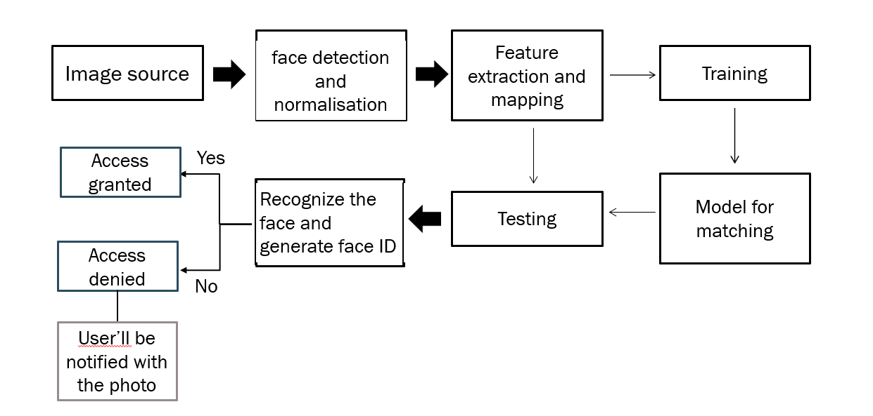
Fig 3.1 Block diagram of face recognition

Explanation for a block diagram of how a face recognition bot work:
1. Input Stage: The process begins with an input stage where an image containing one or more faces is fed into the system. This could be from a camera feed, a static image file, or a video stream.
2. Preprocessing: The input image undergoes preprocessing to enhance its quality and standardize it for better recognition. This stage may include operations such as resizing, normalization, and noise reduction.
3. Face Detection: The preprocessed image is then passed through a face detection module. This module identifies and localizes human faces within the image. Common techniques for face detection include Viola-Jones algorithm, Histogram of Oriented Gradients (HOG), and Convolutional Neural Networks (CNNs).
4. Feature Extraction: Once the faces are detected, the system extracts key features from each face. These features capture unique characteristics of the face, such as the arrangement of eyes, nose, and mouth, as well as the overall facial structure. Feature extraction can be done using techniques like Principal Component Analysis (PCA), Local Binary Patterns (LBP), or Deep Learning-based methods.
5. Face Recognition Model: The extracted features are then compared against a database of known faces to recognize the identities. This database contains a collection of pre-registered faces along with their corresponding features. The recognition process can be performed using various algorithms, including Eigenfaces, Fisherfaces, Support Vector Machines (SVM), or Deep Learning-based approaches like Convolutional Neural Networks (CNNs).
6. Decision Making: Based on the similarity between the extracted features and the faces in the database, the system makes a decision regarding the identity of the person in the input image. If a match is found above a certain threshold, the system concludes that the person has been recognized.
7. Output Stage: Finally, the result of the face recognition process is communicated to the user or another system. This could involve displaying the recognized person's name, triggering an action based on the identity (e.g., granting access to a secured area), or simply logging the result for future reference.
Each block in this diagram represents a distinct stage or component of the face recognition system, and together they form a pipeline that processes input images and produces corresponding recognition results.

FLOWCHART
Creating a flowchart for a face recognition bot involves breaking down the steps and decision points involved in the process. Here's an explanation of the flowchart:
1. Start: The process begins here.
2. Capture Image: The bot captures an image using a camera or webcam.
3. Face Detection: The captured image is analyzed to detect any faces present. This step may involve using algorithms like Haar cascades or deep learning-based methods for face detection.
4. Is Face Detected? A decision point where the bot checks if a face is detected in the captured image. If Yes: Proceed to the next step. If No: The bot may prompt the user to try again or terminate the process.
5. Face Recognition: If a face is detected, the bot performs face recognition to identify the person in the image. This step involves comparing the detected face with a database of known faces.
6. Is the Person Recognized? After performing face recognition, the bot checks if the person is recognized based on the database. If Yes: The bot may provide information about the recognized person or perform a specific action associated with them. If No: The bot may prompt the user to register the person or take other appropriate actions.
7. End: The process ends here.
This flowchart outlines the basic steps involved in a face recognition bot. Depending on the specific requirements and functionalities, additional steps or decision points may be included in the flowchart. For instance, there could be error handling steps, database management steps, or integration with other systems.

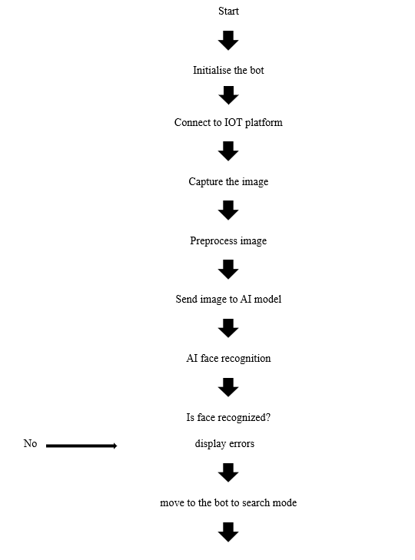
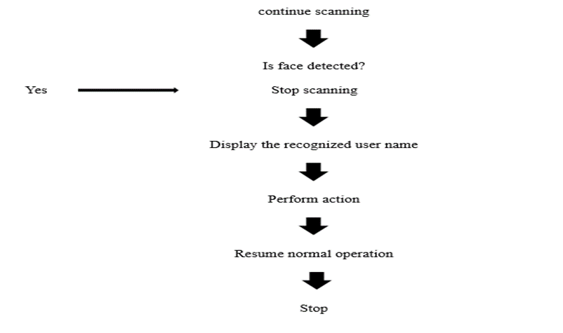

3.3 IMPLEMENTATION
As on the connection part we use just 4 components raspberry pi, pi camera, servo motor and OLED.
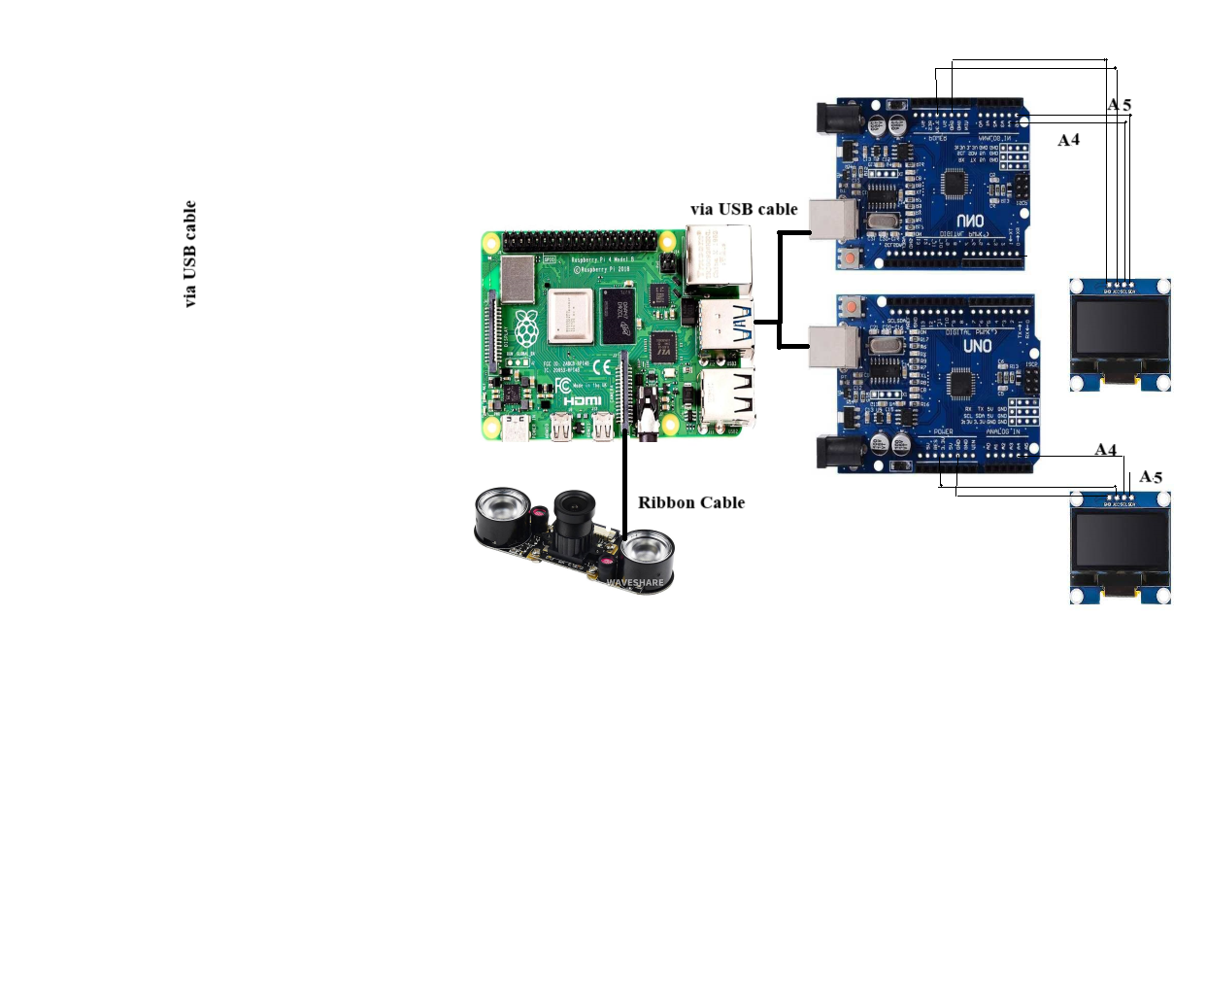
Fig 3.2 Implementation

OLED has 4 pins 5V power, ground, SCL (serial clock pin), SDA(serial data pin)
- SDA of both the OLED is connected to A4 of Arduino UNO
SCL of both the OLED is connected to A5 of Arduino UNO
VCC and GND to 3.3V and GND of Arduino UNO respectively.
- Raspberry pi and arduino UNO are connected using a USB cable
REEE52 night vision camera is connected to camera slot present in the raspberry pi via a ribbon cable

CHAPTER 4
HARDWARE AND SOFTWARE COMPONENTS
4.1 HARDWARE COMPONENTS
4.1.1 SERVO MOTOR
Servo motors come in various types, each with its own characteristics and applications. Here are some common types of servo motors: DC Servo Motors, AC Servo Motors, Brushed Servo Motors, Brushless Servo Motors, Linear Servo Motors, Analog Servo Motors, Digital Servo Motors. These are some of the common types of servo motors, each suited for different applications based on factors such as precision requirements, power source, and environmental conditions.
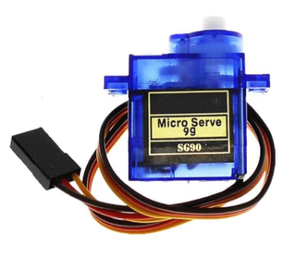
Fig 4.1 Servo Motor
This servo motor is designed to operate at 5v. It’s important to provide the motor with the specified voltage to ensure proper functionality without causing damage. It takes 0.1 seconds for the servo meter to move 60 degrees. This indicates the speed at which the motor responds to commands to change its position. For instance, if you want the motor to move 90 degrees, it might take around 0.15 seconds. The motor has a range of motion from 0 degrees to 180 degrees. The range allows for a precise control over angular movement within the span.
4.1.2 OLED SSD1306
OLED (Organic Light-Emitting Diode) displays come in various types based on their structure, construction, and intended applications. Here are some common types of OLED displays: Passive Matrix OLED (PMOLED), Active Matrix OLED (AMOLED), Transparent OLED, Flexible OLED, Top-Emitting OLED, White OLED (WOLED), RGB OLED.
These are some of the common types of OLED displays, each with its own advantages and applications based on factors such as flexibility, transparency, resolution, and power efficiency.
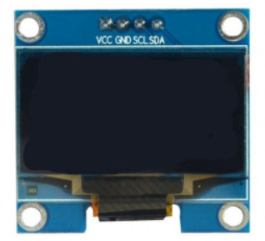
Fig 4.2 OLED SSD1306

The SSD1306 is an integrated circuit that controls OLED displays, managing the display's memory and commands to render content. The SSD1306 typically supports various resolutions, but a common configuration is 128x64 pixels. This means it can display 128 columns and 64 rows of pixels, providing a reasonably high-resolution display in a compact size. Most SSD1306-driven OLED displays are monochrome, usually displaying content in white or blue against a black background. Each pixel is controlled individually, allowing for the display of text, graphics, and basic shapes. OLEDs are known for their efficiency in power consumption, especially when displaying darker colors since they don't require a backlight. Showing messages like "Ready for Recognition," "Face Detected," or "Access Granted/Denied" to indicate the system's status. Providing visual cues or animations during the face detection or recognition process to make the system interaction more user-friendly.
4.1.3 RASPBERRY PI BOARD
Raspberry Pi is a series of single-board computers (SBCs) developed by the Raspberry Pi Foundation. Over the years, several models of Raspberry Pi have been released, each offering different specifications and features. Here are some of the main types of Raspberry Pi boards:
Raspberry Pi 1 Model A/B/A+/B+, Raspberry Pi 2 Model B, Raspberry Pi 3 Model B/B+, Raspberry Pi 4 Model B, Raspberry Pi Zero/W, Raspberry Pi Compute Module.
These are some of the main types of Raspberry Pi boards available, each offering different capabilities and target applications.
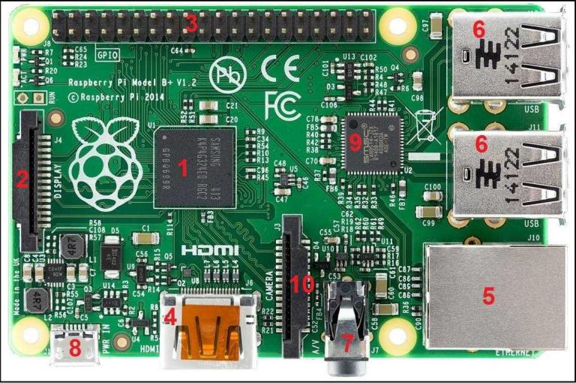
Fig 4.3 Raspberry pi
The Raspberry Pi 4 Model B is the latest product in the popular Raspberry Pi range of computers. It offers ground-breaking increases in processor speed, multimedia performance, memory, and connectivity compared to the prior-generation Raspberry Pi 3 Model B+, while retaining backwards compatibility and similar power consumption. This product’s key features include a high-performance 64-bit quad-core processor, dual-display support at resolutions up to 4K via a pair of micro-HDMI ports, hardware video decode at up to 4Kp60, up to 4GB of RAM, dual-band 2.4/5.0 GHz wireless LAN, Bluetooth 5.0, Gigabit Ethernet, USB 3.0, and PoE capability (via a separate PoE HAT add-on).The dual-band wireless LAN and Bluetooth have modular compliance certification, allowing the board to be designed into end products with significantly reduced compliance testing, improving both cost and time to market. Raspberry Pi is a compact, affordable computer that can run various applications. It's often used for high-level processing, like running the face recognition algorithm. In a face recognition bot Raspberry Pi can process complex algorithms to recognize faces, manage databases of recognized faces, and control the overall functioning of the bot. The Raspberry Pi will serve as the main controller for the face recognition bot. It will handle the image processing, face recognition, and communication with Arduino boards. Connect the Raspberry Pi to the Arduino boards using USB cables. Utilize GPIO pins for any additional connections, like triggering the camera.
4.1.4 REEE52 NIGHT VISION CAMERA
Raspberry Pi offers several camera modules designed for various purposes. As of my last update, there are primarily three main types: Raspberry Pi Camera Module V1, Raspberry Pi Camera Module V2, Raspberry Pi High-Quality Camera. These camera modules can be used for various applications such as photography, video streaming, computer vision projects, and more, depending on the user's requirements.
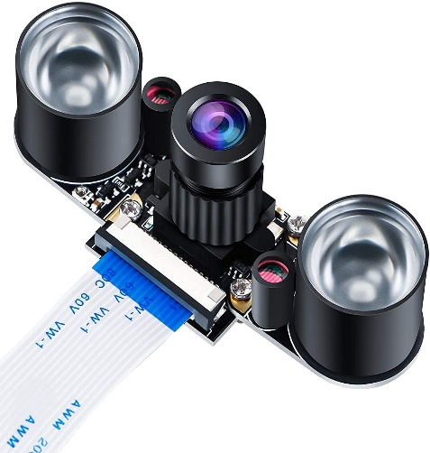
Fig 4.4 night vision camera

- Infrared (IR) Illumination
Many night vision cameras utilize infrared LEDs to illuminate the scene. These LEDs emit light that is invisible to the human eye but is detectable by the camera's sensor, allowing it to capture images even in complete darkness.
- Image Sensors
Night vision cameras may use specialized image sensors optimized for low-light conditions. These sensors are often more sensitive to light than traditional sensors, enabling them to produce clearer images in the dark.
- Resolution
The resolution of the camera's image sensor determines the clarity of the captured images and videos. Higher resolution sensors generally produce sharper images, but they may also be more expensive.
- Recording Capabilities
Night vision cameras may have built-in storage or support for external storage devices such as SD cards or network-attached storage (NAS). They may also offer features like motion detection and scheduled recording.
- Connectivity
Many night vision cameras offer connectivity options such as Wi-Fi or Ethernet, allowing you to access live streams remotely through a smartphone app or web browser. Some cameras also support two-way audio communication, enabling you to listen and speak through the camera.
4.1.5 HDMI TO VGA CONVERTER
HDMI means High-Definition Multimedia Interface, a standard for simultaneously transmitting digital video and audio from a source, such as a computer or TV cable box, to a computer monitor, TV or projector.

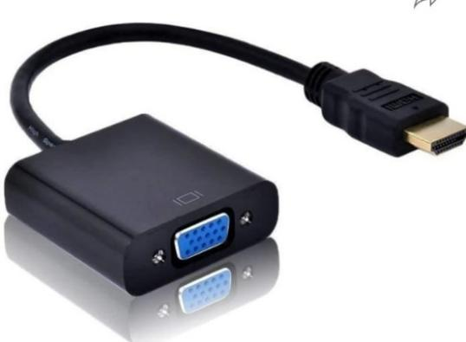
Fig 4.5 HDMI to VGA converter
- Input and Output Connections
The converter has an HDMI input port where you plug in the HDMI cable from your source device. The HDMI cable carries both audio and video signals.On the output side, there's a VGA port where you connect a VGA cable. VGA (Video Graphics Array) is an older analog video standard commonly found in older displays, projectors, and monitors.
- Signal Conversion
The converter essentially translates the digital HDMI signal into an analog VGA signal. HDMI carries digital signals, while VGA uses analog signals. The converter performs this conversion so that the VGA-compatible display or projector can properly receive and display the video signal.
- Resolution Conversion
The converter also handles resolution conversion. HDMI typically supports higher resolutions than VGA. The converter adjusts the resolution of the incoming HDMI signal to match the capabilities of the VGA display. This might involve scaling down the resolution to fit within the VGA's capabilities.
- Power Supply
Some HDMI to VGA converters are powered solely through the HDMI connection, while others may require an additional power source, such as a USB port. This extra power may be necessary for the conversion process, especially if the HDMI signal is particularly strong or if there are additional features like audio extraction.
- Audio Handling
HDMI carries both video and audio signals, but VGA only carries video. If you want to transmit audio along with the video, some converters come with an additional audio output port, usually a 3.5mm audio jack, where you can connect speakers or headphones. However, not all converters support audio conversion.
- Compatibility and Plug-and-Play
Most HDMI to VGA converters are plug-and-play devices, meaning you simply connect them between your HDMI source and VGA display without needing to install any additional software. They're typically compatible with a wide range of devices and operating systems.
4.1.6 ARDUINO UNO
The Arduino Uno is a popular micro controller board based on the ATmega328P chip. It's widely used for prototyping and creating various electronic projects due to its simplicity and versatility. The Uno board provides digital and analog input/output pins, along with power pins, which can be programmed to interact with sensors, motors, LEDs, and other electronic components.
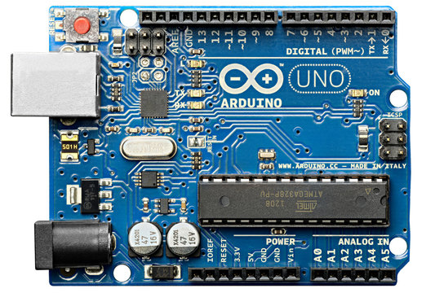
Fig 4.6 ARDUINO UNO
- Versatile Input/Output Pins: Equipped with 14 digital input/output pins, 6 of which support PWM output, and 6 analog input pins, enabling interfacing with a wide range of sensors and actuators.
- Multiple Power Options: Accepts input voltage from both USB connection (5V) and external power supply (7-12V), providing flexibility in power source selection.
- Easy Programming: Programmed using the Arduino Software (IDE), offering a simplified version of C/C++ programming language, making it accessible for beginners while providing advanced features for experienced users.
- Robust Development Ecosystem: Supported by a vast community of enthusiasts and professionals, with extensive documentation, tutorials, and libraries available online, facilitating rapid prototyping and troubleshooting.
- Compact Form Factor: Compact dimensions (68.6 mm x 53.4 mm) and lightweight design make it suitable for embedded systems and portable projects.
- Integrated Development Tools: Includes built-in LED connected to pin 13 for basic debugging, reset button for easy microcontroller reset, and ICSP header for in-circuit programming and firmware updates.
- Stable Performance: Utilizes a 16 MHz crystal oscillator for precise timing functions, ensuring stable and reliable operation in various applications.
4.2 SOFTWARE COMPONENTS
4.2.1 PUTTY
- Remote Terminal Access
PuTTY serves as a conduit for establishing secure shell (SSH) connections to the Raspberry Pi from external devices. This capability empowers project stakeholders to remotely access the command-line interface (CLI) of the Raspberry Pi, enabling the execution of commands, configuration adjustments, and system administration tasks without necessitating direct physical access to the device.
- Configuration Management
PuTTY facilitates the remote configuration and management of the Raspberry Pi's settings and parameters. This includes network configuration, software installation, system updates, and other administrative tasks crucial to the project's operational efficiency and functionality.
- Diagnostic and Debugging Capabilities
Through PuTTY, project participants can remotely diagnose and debug issues encountered on the Raspberry Pi. By accessing system logs, reviewing error messages, and executing diagnostic commands via PuTTY's interface, stakeholders can identify and resolve technical challenges promptly, thereby enhancing the project's robustness and reliability.
4.2.2 THONNY
Thonny is an Integrated Development Environment (IDE) tailored for novice programmers learning Python, specifically designed to simplify the coding process and provide a user-friendly interface. Offering features such as a code editor, debugger, and interactive Python shell, Thonny facilitates the development and testing of Python code with ease and efficiency. Its intuitive design and built-in tools make it an ideal platform for beginners to grasp programming concepts and refine their coding skills.In the context of our project conducted on the Raspberry Pi platform and utilizing the Raspberry Pi OS, Thonny serves as a pivotal tool for the development of our facial recognition system. Leveraging Thonny's capabilities, we are able to write, debug, and optimize the Python code powering our facial recognition algorithms. By utilizing Thonny within the Raspberry Pi environment, we ensure seamless integration and efficient development workflow, enabling us to achieve project objectives effectively and with precision.
4.2.3 VNC
Virtual Network Computing (VNC) is a software tool that enables remote access and control of a computer's graphical desktop interface over a network connection. In the context of our project, which involves developing a facial recognition system using Raspberry Pi, VNC serves as a means to facilitate remote interaction with the Raspberry Pi's desktop environment from a separate device, such as a laptop. By establishing a VNC connection between the Raspberry Pi and the laptop, we can remotely configure, administer, and monitor the Raspberry Pi without the need for direct physical access to the device. This capability streamlines the development process by allowing us to efficiently deploy and manage the facial recognition software on the Raspberry Pi while leveraging the computational resources and convenience of our laptop. Thus, VNC serves as a crucial component in our project infrastructure, enabling seamless collaboration and remote management of the Raspberry Pi-based system.
4.2.4 OPEN CV
OpenCV, or Open-Source Computer Vision Library, is an open-source computer vision and machine learning software library. It provides a comprehensive set of tools, algorithms, and functions for various image and video processing tasks, making it widely used in fields such as robotics, augmented reality, biometrics, surveillance, and medical imaging, among others.
- Image Processing
OpenCV offers a wide range of functions for basic and advanced image processing tasks, including image filtering, transformation, morphological operations, histogram analysis, and color space conversion.
- Feature Detection and Description
OpenCV provides algorithms for detecting and describing features in images, such as corners, edges, keypoints, and descriptors. These features are essential for tasks like object recognition, image stitching, and motion tracking.
- Object Detection and Recognition
OpenCV includes pre-trained models and algorithms for detecting and recognizing objects in images and videos. This includes popular techniques such as Haar Cascade classifiers, Histogram of Oriented Gradients (HOG), and deep learning-based methods.
4.2.5 DLIB
- Facial Detection Model
Dlib utilizes a combination of machine learning algorithms, particularly ensemble learning methods, to build a highly effective face detection model. The model has been trained on a diverse dataset containing images with various poses, lighting conditions, and backgrounds.
- HOG Feature Descriptor
One of the key components of dlib's face detection algorithm is the Histogram of Oriented Gradients (HOG) feature descriptor. HOG captures the local appearance and shape information of objects, making it well-suited for detecting objects like faces in images.
- Sliding Window Technique
Dlib's face detection algorithm employs a sliding window technique to scan the input image at multiple locations and scales. At each window position, the HOG feature descriptor is computed, and a classifier evaluates whether the window contains a face based on learned patterns and features.

- Cascade of Classifiers
Similar to other face detection methods like the Viola-Jones algorithm, dlib's face detector uses a cascade of classifiers to efficiently discard non-face regions early in the process. This cascade structure helps reduce the computational complexity and speeds up the detection process.
4.3 WORKING
- IMAGE CAPTURE
The system begins by capturing a live photo of the person using the Raspberry Pi camera module. This photo serves as the reference image against which subsequent images will be compared for facial recognition.
- IMAGE PROCESSING
Once the reference image is captured, the system processes the images of the person using dlib and OpenCV libraries. Image processing steps may include resizing, normalization, and feature extraction to prepare the images for comparison.
- LIVE STREAM INITIATION
Upon completion of image processing, the system initiates the live camera stream. The live stream interface displays the reference photo of the person.
- FACIAL RECOGNITION
As the live camera stream starts, the system continuously analyzes incoming frames to detect faces using dlib and OpenCV. When a face is detected in the live stream, the system compares it with the reference image using facial recognition algorithms implemented with dlib. If a match is found between the detected face and the reference image, the system identifies the person and displays their name above their head on the live stream interface.
- REAL-TIME IDENTIFICATION
As the person moves within the camera's field of view, the system dynamically tracks their face using techniques provided by the imutils library. It continuously updates the displayed name in real-time as the person's face moves within the frame.

CHAPTER 5
CONCLUSION
5.1 ADVANTAGES AND DISADVANTAGES
Advantages
- Enhanced Security: Face recognition bots provide a high level of security by accurately identifying individuals based on their facial features. This can be particularly useful in sensitive areas such as airports, government buildings, and financial institutions.
- Convenience: They offer convenience by eliminating the need for physical keys, ID cards, or passwords. Users can simply use their face to gain access, saving time and effort.
- Accuracy: Advanced algorithms used in face recognition bots can achieve high levels of accuracy in identifying individuals, minimizing the chances of false positives or false negatives.
- Automation: Face recognition bots can automate various processes such as attendance tracking, access control, and identity verification, reducing the need for manual intervention and streamlining operations.
- Customization: They can be customized to suit specific requirements and scenarios, such as adjusting sensitivity levels, integrating with existing security systems, or incorporating additional security measures like two-factor authentication.
- Scalability: Face recognition bots are scalable and can handle large volumes of data and users, making them suitable for deployments in both small-scale and large-scale environments.
- Analytics: They can provide valuable analytics and insights by tracking and analyzing data related to people's movements, behavior patterns, and demographics, which can be useful for businesses in understanding customer preferences or optimizing operations.
- Contactless Interaction: Especially in times of public health concerns like pandemics, face recognition bots offer a contactless means of identification, reducing the risk of spreading contagious diseases through physical contact with surfaces such as keypads or fingerprint scanners.
- User Experience: They offer a seamless and futuristic user experience, enhancing the overall perception of a facility or service by users.
- Integration: Face recognition bots can be integrated with other technologies such as surveillance cameras, smart locks, or mobile applications, creating a comprehensive security ecosystem.
Disadvantages:
- Privacy Concerns: There are significant privacy concerns surrounding the use of face recognition technology. Users may feel uncomfortable with their facial data being collected and stored, especially if they are not adequately informed about how it will be used and protected.
- Bias and Inaccuracy: Face recognition algorithms can exhibit bias, leading to inaccuracies, particularly when identifying individuals with darker skin tones or non-traditional facial features. This can result in discrimination and false identifications, leading to potential legal and ethical issues.
- Security Risks: Despite their intended use for security purposes, face recognition systems can be vulnerable to hacking or spoofing. For example, facial recognition systems have been tricked by using photos or masks that closely resemble the target individual's face.
- Misuse of Data: There is a risk of misuse of facial data collected by recognition systems. This data could be exploited for surveillance purposes, tracking individuals without their consent, or for other potentially invasive purposes.
- Lack of Regulation: There is often a lack of comprehensive regulation governing the use of face recognition technology, leading to inconsistencies in how it is implemented and safeguarded across different contexts and jurisdictions.
- Civil Liberties Concerns: Face recognition technology raises concerns about civil liberties and the right to privacy. Critics argue that widespread deployment of facial recognition systems could lead to increased government surveillance and erosion of individual freedoms.
- Potential for Abuse: In the wrong hands, face recognition technology could be used for malicious purposes, such as stalking, harassment, or targeting specific groups or individuals based on their demographic characteristics.
- Opt-Out Challenges: Individuals may have limited options to opt out of face recognition systems, especially in public spaces where surveillance is prevalent. This lack of control over one's personal data can contribute to feelings of intrusion and loss of autonomy.
- Cost and Implementation Challenges: Implementing face recognition systems can be costly and complex, requiring investment in hardware, software, and infrastructure. Additionally, there may be challenges in integrating these systems with existing security or IT infrastructure.
- Cultural and Social Acceptance: Face recognition technology may face resistance or skepticism from certain cultural or social groups who perceive it as invasive or discriminatory, leading to challenges in its acceptance and adoption.
5.2 SUMMARY
The development of the Face Recognition Bot incorporating servo motors, OLED SSD1360s, Arduino UNO boards, Raspberry Pi board, a Raspberry Pi camera, USB data cable, and a face mask has been a significant endeavour. The integration of these components allowed for the creation of a sophisticated and versatile system capable of recognizing and responding to human faces. The collaboration between Arduino UNO boards and servo motors facilitated precise control over the bot's movements, enhancing its interactive capabilities. The inclusion of OLED SSD1360s provided a visually intuitive interface for monitoring and displaying relevant information during the face recognition process. Leveraging the computational power of Raspberry Pi boards and the Raspberry Pi camera ensured efficient and accurate face detection.
The utilization of servo motors enables precise movement, allowing the bot to efficiently scan its surroundings and focus on detected faces. The Arduino UNO boards act as reliable controllers, managing the servo motors and OLED displays with precision. The integration of Raspberry Pi boards and the Raspberry Pi camera significantly enhances the bot's capabilities, enabling it to capture and process facial data. The use of advanced face recognition algorithms and machine learning techniques further elevates the system's accuracy and efficiency in identifying individuals.
Moreover, the modular design of the system allows for scalability and future enhancements. The USB data cable ensures seamless communication between the Arduino and Raspberry Pi components, establishing a robust connection for data exchange.
Overall, this face recognition bot stands as a testament to the convergence of hardware and software technologies, showcasing the potential of combining Arduino and Raspberry Pi platforms for innovative and practical applications. The successful implementation of this project opens avenues for further research and development in the realm of intelligent robotic systems, with potential applications in security, surveillance, and human-computer interaction. This face recognition bot holds great potential for applications in security, automation, and human-computer interaction. Its ability to accurately identify and track faces showcases the successful integration of hardware components and software algorithms. As technology continues to advance, the face recognition bot represents a compelling example of the convergence of microcontroller-based systems and single-board computers, opening doors to innovative solutions in various domains. The successful amalgamation of hardware components and software functionalities has resulted in a face recognition bot that not only showcases technological prowess but also demonstrates the practical application of such systems. This project serves as a testament to the interdisciplinary nature of robotics and computer vision, offering a glimpse into the potential advancements in the field of human-machine interaction.
As technology continues to advance, this face recognition bot stands as a testament to the exciting possibilities and applications that emerge from the integration of diverse components and the innovative use of emerging technologies. The journey of building this bot has not only provided valuable insights into the intricacies of robotics but also opens the door to further exploration and refinement the realm of artificial intelligence and automation.The development and implementation of a face recognition bot mark a significant stride in the field of artificial intelligence and computer vision.
The ability of such a system to accurately identify and authenticate individuals based on facial features brings about a myriad of potential applications, ranging from enhancing security protocols to streamlining user experiences in various industries. The face recognition bot's success lies in its capacity to adapt and learn from diverse datasets, enabling it to handle a wide array of facial variations and expressions. However, ethical considerations regarding privacy and data security must be carefully addressed to ensure responsible and transparent deployment. In essence, the face recognition bot represents a powerful tool with the ability to streamline and secure processes in both public and private domains.

CHAPTER 6
RESULT
Detected an authorised user
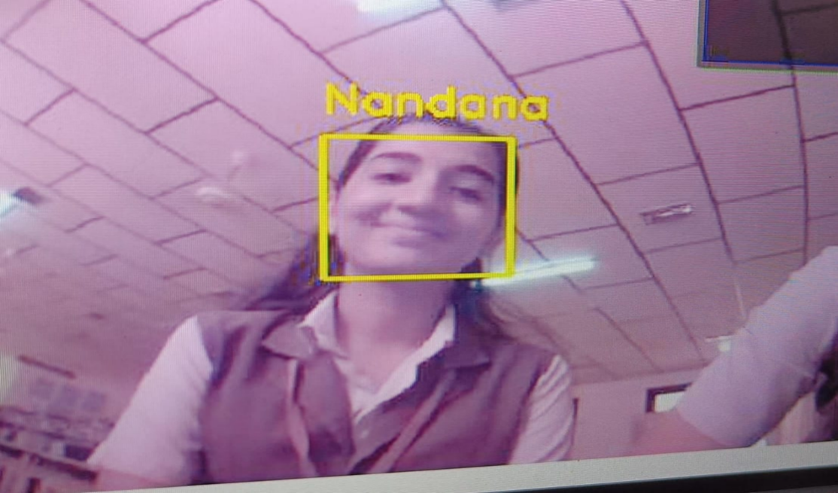
Fig 6.1 Detected an unauthorised user
Detecting an unauthorised user
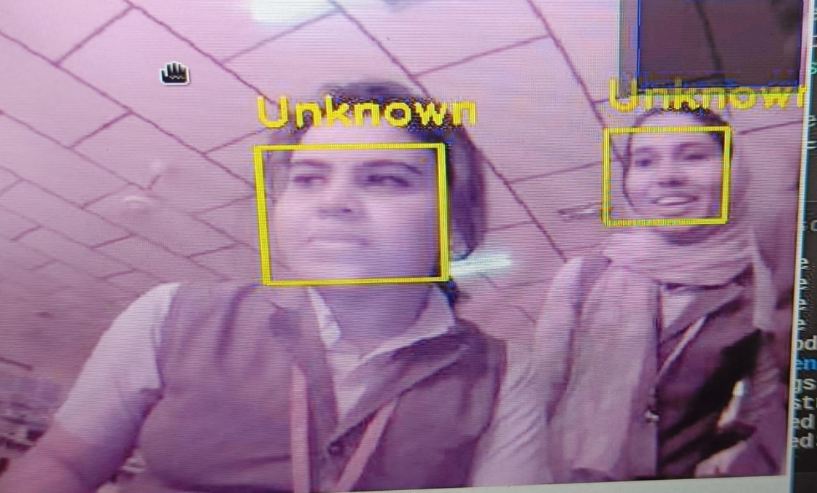
Fig 6.2 Detected an unauthorised user

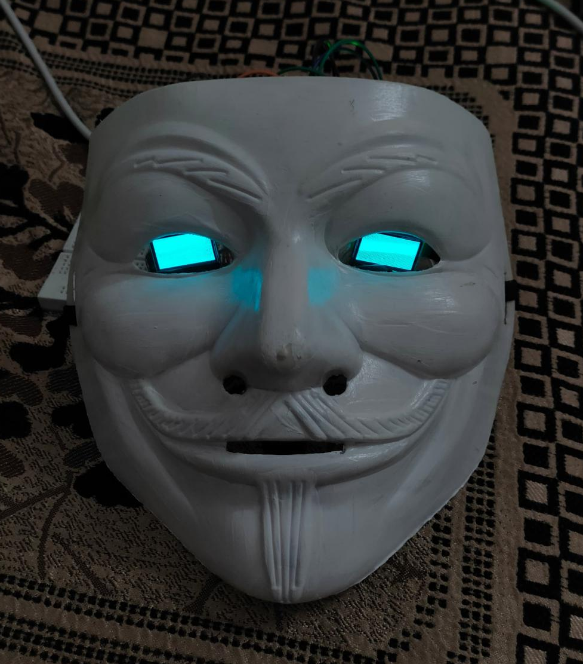
Fig 6.3 Final Product

REFERENCE
- N. Bellustin, Y. Kalafati, Kovalchuck, A. Telnykh, O. Shemagina, V. Yakhno, Abhishek Vaish, Pinki Sharma, and Shirshu Verma. 2011. Instant Human Face Attributes Recognition System. IJACSA, Special Issue Artif. Intel.: 112–120.
- Marian Stewart Bartlett, Gwen Littlewort, Ian Fasel, and Javier R. Movellan. 2003. Real Time Face Detection and Facial Expression Recognition: Development and Applications to Human Computer Interaction. In 2003 Conference on Computer Vision and Pattern Recognition Workshop, 53–53.
- J Parris, M Wilber, B Heflin, H Rara, A EI_Barkouky, A Farag, J Movellan, M Castrillon-Santana, J LorenzoNavarro, M. N. Teli, S Marcel. 2011. Face and eye detection on hard datasets. In Biometrics (IJCB), 2011 International Joint Conference on , pp. 1-10. IEEE.
- Zixuan Wang, Jinyun Yan, Cong Pang, David Chu, and Hamid Aghajan. 2012. Who is Here: Location Aware Face Recognition. Proceedings of the Third International Workshop on Sensing Applications on Mobile Phones: 8:1--8:5.

APPENDIX
import cv2
import os
name = input("Enter Name:") # replace with your name
# Specify the directory to save images
save_dir = r"C:\Users\ASUS\Downloads\facial-recognition-main\dataset"
def create_folder_if_not_exists(directory, name):
folder_path = os.path.join(directory, name)
if not os.path.exists(folder_path):
os.makedirs(folder_path)
print(f"Folder '{name}' created in '{directory}'.")
else:
print(f"Folder '{name}' already exists in '{directory}'.")
# Example usage
create_folder_if_not_exists(save_dir, name)
cam = cv2.VideoCapture(0)
cv2.namedWindow("press space to take a photo", cv2.WINDOW_NORMAL)
cv2.resizeWindow("press space to take a photo", 500, 300)
img_counter = 0
while True:
ret, frame = cam.read()
if not ret:
print("failed to grab frame")
break
cv2.imshow("press space to take a photo", frame)
k = cv2.waitKey(1)
if k % 256 == 27:
# ESC pressed
print("Escape hit, closing...")
break
elif k % 256 == 32:
# SPACE pressed
img_name = os.path.join(save_dir, name,"image_{}.jpg".format(img_counter))
cv2.imwrite(img_name, frame)
print("{} written!".format(img_name))
img_counter += 1
cam.release()
cv2.destroyAllWindows()
# import the necessary packages
from imutils import paths
import face_recognition
#import argparse
#Code to train data
import pickle
import cv2
import os
# our images are located in the dataset folder
print("[INFO] start processing faces...")
imagePaths = list(paths.list_images("dataset"))
# initialize the list of known encodings and known names
knownEncodings = []
knownNames = []
# loop over the image paths
for (i, imagePath) in enumerate(imagePaths):
# extract the person name from the image path
print("[INFO] processing image {}/{}".format(i + 1,
len(imagePaths)))
name = imagePath.split(os.path.sep)[-2]
# load the input image and convert it from RGB (OpenCV ordering)
# to dlib ordering (RGB)
image = cv2.imread(imagePath)
rgb = cv2.cvtColor(image, cv2.COLOR_BGR2RGB)
# detect the (x, y)-coordinates of the bounding boxes
# corresponding to each face in the input image
boxes = face_recognition.face_locations(rgb,
model="hog")
# compute the facial embedding for the face
encodings = face_recognition.face_encodings(rgb, boxes)
# loop over the encodings
for encoding in encodings:
# add each encoding + name to our set of known names and
# encodings
knownEncodings.append(encoding)
knownNames.append(name)
# dump the facial encodings + names to disk
print("[INFO] serializing encodings...")
data = {"encodings": knownEncodings, "names": knownNames}
f = open("encodings.pickle", "wb")
f.write(pickle.dumps(data))
f.close()
# Test
# Import necessary packages
from imutils.video import VideoStream
from imutils.video import FPS
import face_recognition
import imutils
import pickle
import cv2
import time
import os
# Set the name of the current person being recognized
current_name = "Fathima"
# Path to the encodings file (created using a training script)
encodings_file = "encodings.pickle"
# Load the encodings and face data
print("[INFO] Loading encodings and face data...")
with open(encodings_file, "rb") as f:
data = pickle.load(f)
# Initialize the video stream using the laptop's webcam (source 0)
print("[INFO] Starting video stream...")
vs = VideoStream(src=0).start()
# Allow the camera sensor to warm up
time.sleep(2.0)

# Start the FPS counter
fps = FPS().start()
# Main loop to process video frames
while True:
# Capture a frame from the video stream and resize it
frame = vs.read()
frame = imutils.resize(frame, width=500)
# Detect face locations in the frame
boxes = face_recognition.face_locations(frame)
# Compute facial embeddings for each face
encodings = face_recognition.face_encodings(frame, boxes)
names = []
# Loop over each facial embedding
for encoding in encodings:
# Attempt to match the face to known encodings
matches = face_recognition.compare_faces(data["encodings"], encoding)
name = "Unknown" # Default name if the face is not recognized
# Check for matches
if True in matches:
# Get indices of all matched faces
matched_indices = [i for (i, match) in enumerate(matches) if match]
# Create a dictionary to count the total number of times each face was matched
counts = {}
for i in matched_indices:
name = data["names"][i]
counts[name] = counts.get(name, 0) + 1
# Determine the recognized face with the highest count
name = max(counts, key=counts.get)
# Print the name if a new person is recognized
if current_name != name:
current_name = name
print(f"[INFO] New person recognized: {current_name}")
# Append the recognized name to the list
names.append(name)
# Loop over the recognized faces and draw bounding boxes and names
for ((top, right, bottom, left), name) in zip(boxes, names):
# Draw a rectangle around the face
cv2.rectangle(frame, (left, top), (right, bottom), (0, 255, 225), 2)
# Draw the name of the recognized person
y = top - 15 if top - 15 > 15 else top + 15
cv2.putText(frame, name, (left, y), cv2.FONT_HERSHEY_SIMPLEX, 0.8, (0,255,255), 2)
# Display the frame
cv2.imshow("Facial Recognition", frame)
# Check for 'q' key press to quit
if cv2.waitKey(1) & 0xFF == ord('q'):
break
# Update the FPS counter
fps.update()
# Stop the FPS counter and display information
fps.stop()
print(f"[INFO] Elapsed time: {fps.elapsed():.2f} seconds")
print(f"[INFO] Approximate FPS: {fps.fps():.2f}")
# Clean up resources
cv2.destroyAllWindows()
vs.stop()

